**Lesson 09 Demo 01**

**Creating a Next.js Welcome Application**

**Objective:** To create the Next.js application to display a simple welcome message

**Tools required:** Node.js and React.js

**Prerequisites:** None

Steps to be followed:

1. Set up the Next.js project
2. Create the project
3. Run the application

**Step 1: Set up the Next.js project**

1. Open a terminal window and install the third-party modules with the following command:

**npm install -g create-next-app**

1. Create a new project using **create-next-app** command with the options mentioned below:
   * **What is your project named? my-app**
   * **Would you like to use TypeScript? No**
   * **Would you like to use ESLint? No**
   * **Would you like to use Tailwind CSS? No**
   * **Would you like to use ‘src/’ directory? Yes**
   * **Would you like to use App Router? Yes**
   * **Would you like to customize the default import alias (@/*)? No**

1. Open the **MY-APP** folder in the VS Code editor to view the project structure

**Step 2: Create the project**

1. Create a file **next.config.js** that contains the configuration as shown in the code below:

**/** @type {import('next').NextConfig} */**

**const nextConfig = {}**

**module.exports = nextConfig**

1. Create a **package.json** file for project dependencies and scripts with the following code:

**{**

**"name": "my-app",**

**"version": "0.1.0",**

**"private": true,**

**"scripts": {**

**"dev": "next dev",**

**"build": "next build",**

**"start": "next start",**

**"lint": "next lint"**

**},**

**"dependencies": {**

**"react": "^18",**

**"react-dom": "^18",**

**"next": "14.0.4"**

**}**

**}**

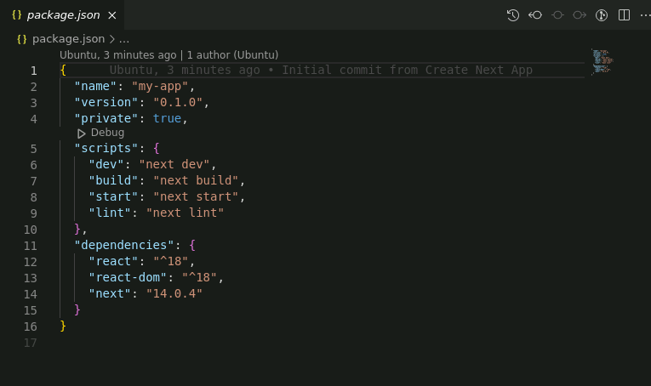

1. Create a **layout.js** file with the following code that is responsible for rendering the **Next.js** component on the server side

**import { Inter } from 'next/font/google'**

**import './globals.css'**

**const inter = Inter({ subsets: ['latin'] })**

**export const metadata = {**

**title: 'Create Next App',**

**description: 'Generated by create next app',**

**}**

**export default function RootLayout({ children }) {**

**return (**

**<html lang="en">**

**<body className={inter.className}>{children}</body>**

**</html>**

**)**

**}**

1. Create **page.js** file with the following code:

**import Image from 'next/image'**

**import styles from './page.module.css'**

**export default function Home() {**

**return (**

**<main className={styles.main}>**

**<div className={styles.description}>**

**<p>**

**Get started by editing&nbsp;**

**<code className={styles.code}>src/app/page.js</code>**

**</p>**

**<div>**

**<a**

**href="https://vercel.com?utm_source=create-next-app&utm_medium=appdir-template&utm_campaign=create-next-app"**

**target="_blank"**

**rel="noopener noreferrer"**

**>**

**By{' '}**

**<Image**

**src="/vercel.svg"**

**alt="Vercel Logo"**

**className={styles.vercelLogo}**

**width={100}**

**height={24}**

**priority**

**/>**

**</a>**

**</div>**

**</div>**

**<div className={styles.center}>**

**<Image**

**className={styles.logo}**

**src="/next.svg"**

**alt="Next.js Logo"**

**width={180}**

**height={37}**

**priority**

**/>**

**</div>**

**<div className={styles.grid}>**

**<a**

**href="https://nextjs.org/docs?utm_source=create-next-app&utm_medium=appdir-template&utm_campaign=create-next-app"**

**className={styles.card}**

**target="_blank"**

**rel="noopener noreferrer"**

**>**

**<h2>**

**Docs <span>-&gt;</span>**

**</h2>**

**<p>Find in-depth information about Next.js features and API.</p>**

**</a>**

**<a**

**href=**[**https://nextjs.org/learn?utm_source=create-next-app&utm_medium=appdir-template&utm_campaign=create-next-app**](https://nextjs.org/learn?utm_source=create-next-app&utm_medium=appdir-template&utm_campaign=create-next-app)

**className={styles.card}**

**target="_blank"**

**rel="noopener noreferrer"**

**>**

**<h2>**

**Learn <span>-&gt;</span>**

**</h2>**

**<p>Learn about Next.js in an interactive course with&nbsp;quizzes!</p>**

**</a>**

**<a href="https://vercel.com/templates?framework=next.js&utm_source=create-next-app&utm_medium=appdir-template&utm_campaign=create-next-app"**

**className={styles.card}**

**target="_blank"**

**rel="noopener noreferrer"**

**>**

**<h2>**

**Templates <span>-&gt;</span>**

**</h2>**

**<p>Explore starter templates for Next.js.</p>**

**</a>**

**<a href="https://vercel.com/new?utm_source=create-next-app&utm_medium=appdir-template&utm_campaign=create-next-app"**

**className={styles.card}**

**target="_blank"**

**rel="noopener noreferrer"**

**>**

**<h2>**

**Deploy <span>-&gt;</span>**

**</h2>**

**<p>**

**Instantly deploy your Next.js site to a shareable URL with Vercel.**

**</p>**

**</a>**

**</div>**

**</main>**

**)**

**}**

1. Create **globals.css** file that contains global CSS styling with the following code:

**:root {**

**--max-width: 1100px;**

**--border-radius: 12px;**

**--font-mono: ui-monospace, Menlo, Monaco, 'Cascadia Mono', 'Segoe UI Mono',**

**'Roboto Mono', 'Oxygen Mono', 'Ubuntu Monospace', 'Source Code Pro',**

**'Fira Mono', 'Droid Sans Mono', 'Courier New', monospace;**

**--foreground-rgb: 0, 0, 0;**

**--background-start-rgb: 214, 219, 220;**

**--background-end-rgb: 255, 255, 255;**

**--primary-glow: conic-gradient(**

**from 180deg at 50% 50%,**

**#16abff33 0deg,**

**#0885ff33 55deg,**

**#54d6ff33 120deg,**

**#0071ff33 160deg,**

**transparent 360deg**

**);**

**--secondary-glow: radial-gradient(**

**rgba(255, 255, 255, 1),**

**rgba(255, 255, 255, 0)**

**);**

**--tile-start-rgb: 239, 245, 249;**

**--tile-end-rgb: 228, 232, 233;**

**--tile-border: conic-gradient(**

**#00000080,**

**#00000040,**

**#00000030,**

**#00000020,**

**#00000010,**

**#00000010,**

**#00000080**

**);**

**--callout-rgb: 238, 240, 241;**

**--callout-border-rgb: 172, 175, 176;**

**--card-rgb: 180, 185, 188;**

**--card-border-rgb: 131, 134, 135;**

**}**

**@media (prefers-color-scheme: dark) {**

**:root {**

**--foreground-rgb: 255, 255, 255;**

**--background-start-rgb: 0, 0, 0;**

**--background-end-rgb: 0, 0, 0;**

**--primary-glow: radial-gradient(rgba(1, 65, 255, 0.4), rgba(1, 65, 255, 0));**

**--secondary-glow: linear-gradient(**

**to bottom right,**

**rgba(1, 65, 255, 0),**

**rgba(1, 65, 255, 0),**

**rgba(1, 65, 255, 0.3)**

**);**

**--tile-start-rgb: 2, 13, 46;**

**--tile-end-rgb: 2, 5, 19;**

**--tile-border: conic-gradient(**

**#ffffff80,**

**#ffffff40,**

**#ffffff30,**

**#ffffff20,**

**#ffffff10,**

**#ffffff10,**

**#ffffff80**

**);**

**--callout-rgb: 20, 20, 20;**

**--callout-border-rgb: 108, 108, 108;**

**--card-rgb: 100, 100, 100;**

**--card-border-rgb: 200, 200, 200;**

**}**

**}**

**\* {**

**box-sizing: border-box;**

**padding: 0;**

**margin: 0;**

**}**

**html,**

**body {**

**max-width: 100vw;**

**overflow-x: hidden;**

**}**

**body {**

**color: rgb(var(--foreground-rgb));**

**background: linear-gradient(**

**to bottom,**

**transparent,**

**rgb(var(--background-end-rgb))**

**)**

**rgb(var(--background-start-rgb));**

**}**

**a {**

**color: inherit;**

**text-decoration: none;**

**}**

**@media (prefers-color-scheme: dark) {**

**html {**

**color-scheme: dark;**

**}**

**}**

**Step 3: Run the application**

1. Open the terminal inside the project and run the application with the following command:

**npm run dev**

1. Open the browser and go to the URL <http://localhost:3000>

1. Edit the file **page.js** with the following code, which is the first Next.js server-side component rendered with the help of the **layout.js** file

**import Image from 'next/image'**

**import styles from './page.module.css'**

**export default function Home() {**

**return (**

**<main className={styles.main}>**

**<div>**

**<h2>Welcome to simple next js application!</h2>**

**</div>**

**</main>**

**)**

**}**

The output will look as follows:

With this, you have successfully created the Next.js application to display a simple welcome message.